Q 1. Java program to print welcome message ?

**package** studentMngtSystem;

**public** **class** Hello {

**public** **static** **void** main(String[] args)

{

System.***out***.println("Welcome");

}

}

Output



--------------------------------------------------------------------------------------------------------------------------------------

Q 2 Java program to print sum of three float numbers ?

**package** studentMngtSystem;

**public** **class** Float {

**public** **static** **void** main(String[] args) {

**float** num1=10.80f,num2=30.55f,num3=80.35f,sum;

sum = num1+num2+num3;

System.***out***.println("sum"+ sum);

}

}

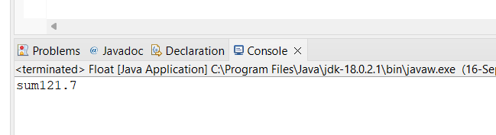

--------------------------------------------------------------------------------------------------------------------------

Q 3 Java Program to Swap Two Numbers?

**package** studentMngtSystem;

**public** **class** Swap {

**public** **static** **void** main(String args[]) {

**int** first=20;

**int** second=30;

System.***out***.println("Before swap");

System.***out***.println("First value :"+first);

System.***out***.println("Second value :"+second);

**int** temp = first;

first = second;

second = temp;

System.***out***.println("After swap");

System.***out***.println("First value :"+first);

System.***out***.println("Second value :"+second);

}

}

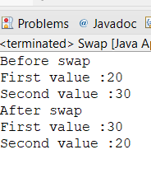

Q 4 Wap to check if number is even or odd ?

**package** studentMngtSystem;

**public** **class** Main {

**public** **static** **void** main(String[] args) {

**int** number = 30;

//checking whether the number is even or odd

**if** (number % 2 == 0)

System.***out***.println(number + " is Even");

**else**

System.***out***.println(number + " is odd");

}

}

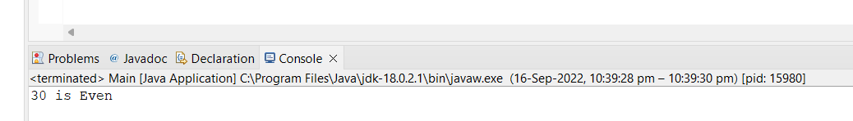

Q 5 wap to check from three given number  that whether a number is greater than or equal to 20 and less than other numbers .print appropriate message ?

**package** studentMngtSystem;

**public** **class** Greaterorsmaller {

**public** **static** **void** main(String[] args) {

**double** n1 =10, n2 = 20, n3 = 15;

**if**( n1 >= n2 && n1 >= n3)

System.***out***.println(n1 + " is the largest number.");

**else** **if** (n2 >= n1 && n2 >= n3)

System.***out***.println(n2 + "is the largest number.");

**else**

System.***out***.println(n3 + " is the largest number.");

}

}

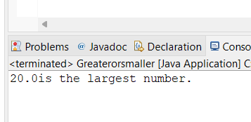

Q 8 wap to check if two given integer value is in range of 18 and 100 print eligible for voting else not eligible ?

**package** studentMngtSystem;

**import** java.util.Scanner;

//Q 8 wap to check if two given integer value is in range of 18 and 100

// print eligible for voting else not eligible .

**public** **class** Question8 {

**public** **static** **void** main(String[] args) {

// **TODO** Auto-generated method stub

Scanner s = **new** Scanner(System.***in***);

System.***out***.print("enter your age = ");

**int** a= s.nextInt();

**if**(a>18 && a<100)

System.***out***.print("you are Eligible for voting");

**else**

System.***out***.print("you are Not Eligible for voting" );

}

}

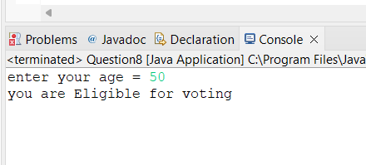

Q 9 wap to print average of  given five subjects marks of student and check if average >=40 print Pass else print fail ?

**package** studentMngtSystem;

**import** java.util.Scanner;

//Q 9 wap to print average of given five subjects

// marks of student and check if average >=40 print Pass else print fail

**public** **class** Question9 {

**public** **static** **void** main(String[] args) {

// **TODO** Auto-generated method stub

Scanner s = **new** Scanner(System.***in***);

System.***out***.print("Enter you 5 Subject marks = ");

**int** a=s.nextInt();

**int** b=s.nextInt();

**int** c=s.nextInt();

**int** d=s.nextInt();

**int** e=s.nextInt();

**float** g = (a+b+c+d+e)/5f;

System.***out***.println("Your avg marks is = " +g);

**if**(g>40)

System.***out***.println("you are pass");

**else**

System.***out***.print("you are fail");

}

}

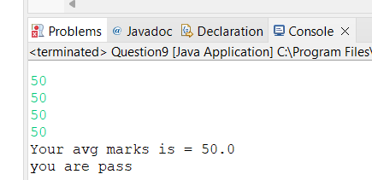

Q10 WAP to ask name ,age and salary of an employee and print on console ?

**package** studentMngtSystem;

**import** java.util.Scanner;

//Q10 WAP to ask name ,age and salary of an employee and print on console.

**public** **class** Question10 {

**public** **static** **void** main(String[] args) {

// **TODO** Auto-generated method stub

Scanner s = **new** Scanner(System.***in***);

System.***out***.println("please enter your name");

String a= s.nextLine();

System.***out***.println("please enter your age");

**int** b = s.nextInt();

System.***out***.println("please enter your salary");

**float** c = s.nextFloat();

System.***out***.println("name = " + a +", age = " +b +", salary = " +c);

}

}

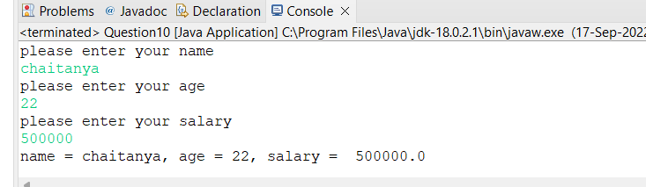

Q 11 wap  that ask two numbers from user and print greater number among two ?

**package** studentMngtSystem;

**import** java.util.Scanner;

//Q 11 wap that ask two numbers from user and print greater number among two

**public** **class** Question11 {

**public** **static** **void** main(String[] args) {

// **TODO** Auto-generated method stub

Scanner s= **new** Scanner (System.***in***);

System.***out***.print("Enter 1st number = ");

**int** a=s.nextInt();

System.***out***.print("Enter 2nd number = ");

**int** b=s.nextInt();

**if**(a>b)

System.***out***.print("1st number is greater");

**else**

System.***out***.print("2nd number is greater");

}

}

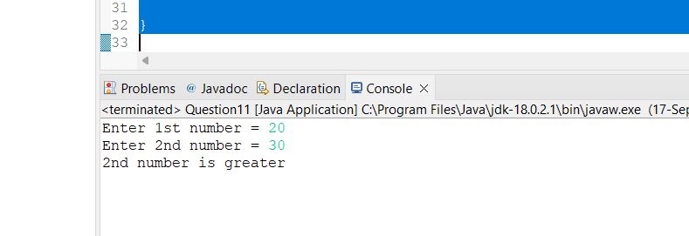

Q 12  wap to ask product name and price of product from user and calculate discount i.e   
if price > 2000 then discount is 10 percent of price   
else discount is 7 % of price?

// Java Program to find the Discount Percentage

import java.util.*;

import java.lang.*;

import java.io.*;

class GFG{

// Function to find the Discount Percentage

static float discountPercentage(float S, float M)

{

// Calculating discount

float discount = M - S;

// Calculating discount percentage

float disPercent = (discount / M) * 100;

return disPercent;

}

// Driver code

public static void main(String args[])

{

int M, S;

M = 120;

S = 100;

System.out.printf("%.2f",discountPercentage(S,M));

System.out.println("%");

M = 1000;

S = 500;

System.out.printf("%.2f",discountPercentage(S,M));

System.out.println("%");

}

}

